To Make USB Drive work with FloppyFw
Install Bootice Version 0.78 . I am Using KingSton Data Traveller in my case
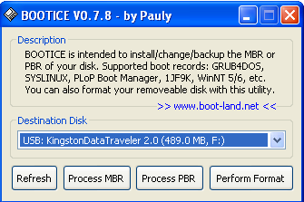
Select Process PBR , Then Select SYSLINUX 3.86 , Then Select Install / Config .
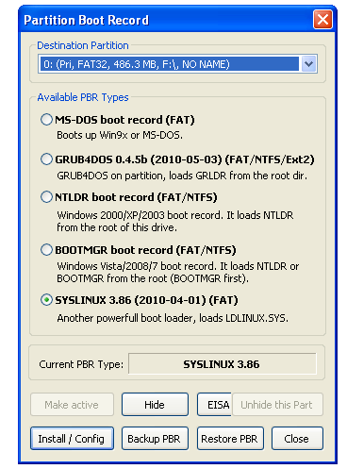
Then Go to
http://www.zelow.no/floppyfw/download/floppyfw-3.0/floppyfw-3.0.14/floppyfw-3.0.14-flash.tar.bz2
Extract this ZIP File and Paste all the files in Root of the USB DRIVE
